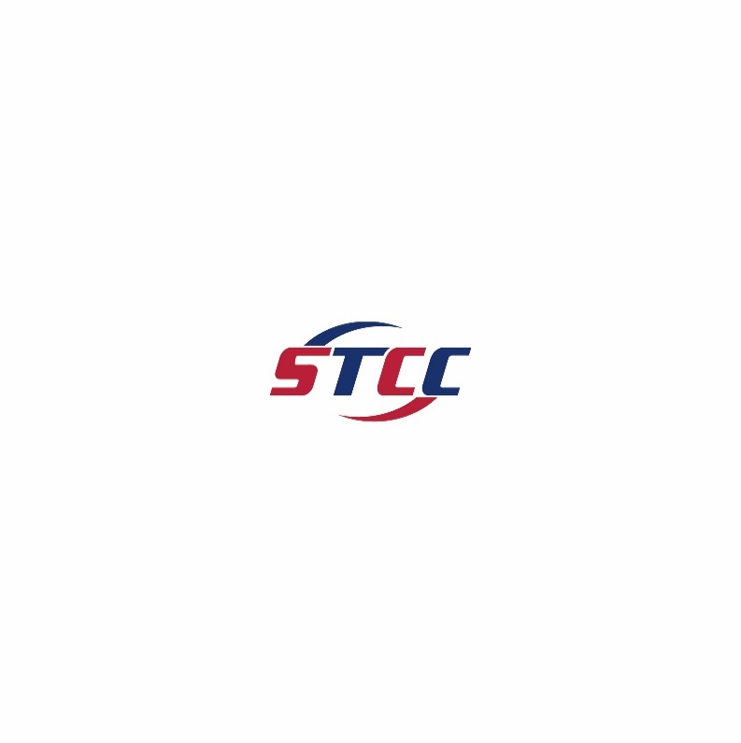

**STCC INTERNATIONAL PARK**

**_____________________________________________________________________________________**

**Cost of Living in Chengdu**



**SUNELS TECHNOLOGY AND CAPITAL CORPORATION**

**409 MINNISINK ROAD TOTOWA, NEW JERSEY 07512**

**MAIN TELEPHONE: 973-837-8900 WEBSITE: WWW.STCCPARK.COM**